**PROJECT REPORT**

1. **INTRODUCTION**
   1. **Overview**

VOYAGE VISTA is a cutting-edge platform that enables Uber to conduct exploratory analysis on large-scale data sets. It leverages advanced techniques such as machine learning, natural language processing, and interactive visualization to provide insights that can inform strategic decisions and optimize business outcomes. VOYAGE VISTA allows analysts to ask complex questions, discover patterns, and generate hypotheses in a fast and intuitive way. It also supports collaboration and communication among stakeholders, facilitating the dissemination and adoption of data-driven insights across the organization. VOYAGE VISTA is a powerful tool that empowers Uber to harness the full potential of its data and achieve its vision of becoming a global leader in mobility and delivery.

* 1. **Purpose**

VOYAGE VISTA is a cutting-edge platform that enables Uber to conduct expeditionary analysis on large-scale data sets. It leverages the power of cloud computing, machine learning, and visualization to provide insights that can drive strategic decisions and optimize business outcomes. VOYAGE VISTA allows analysts to explore data from multiple sources, perform complex queries, and generate interactive dashboards that can be shared with stakeholders. VOYAGE VISTA is not just a tool, but a mindset that empowers Uber to discover new opportunities, solve challenging problems, and create value for our customers and partners.

**2. PROBLEM DEFINITION & DESIGN THINKING**

**2.1 EMPATHY MAP**

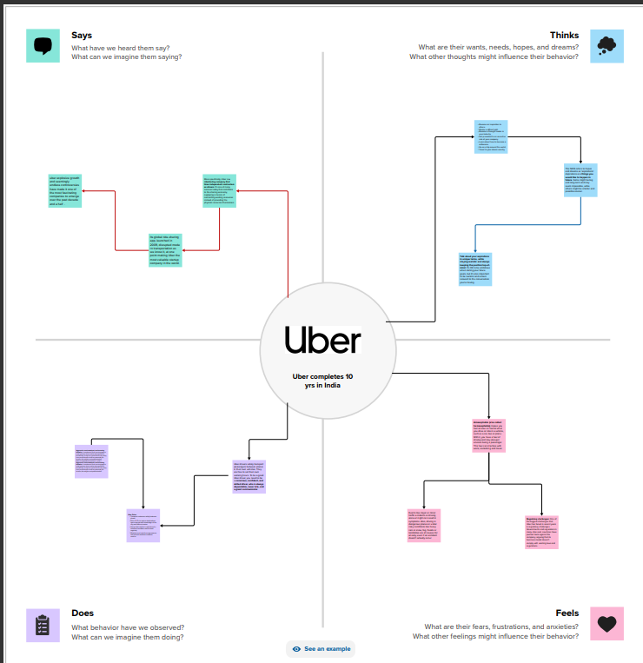

VOYAGE VISTA is a new initiative by Uber that aims to provide insights from expeditionary analysis of various destinations around the world. Expeditionary analysis is a method of exploring and understanding the cultural, social, economic, and environmental aspects of a place through immersive and participatory research. VOYAGE VISTA seeks to illuminate the diverse and complex realities of different regions and communities, and to share their stories, challenges, and opportunities with a global audience. By doing so, VOYAGE VISTA hopes to foster empathy, curiosity, and collaboration among travellers, researchers, and local stakeholders.

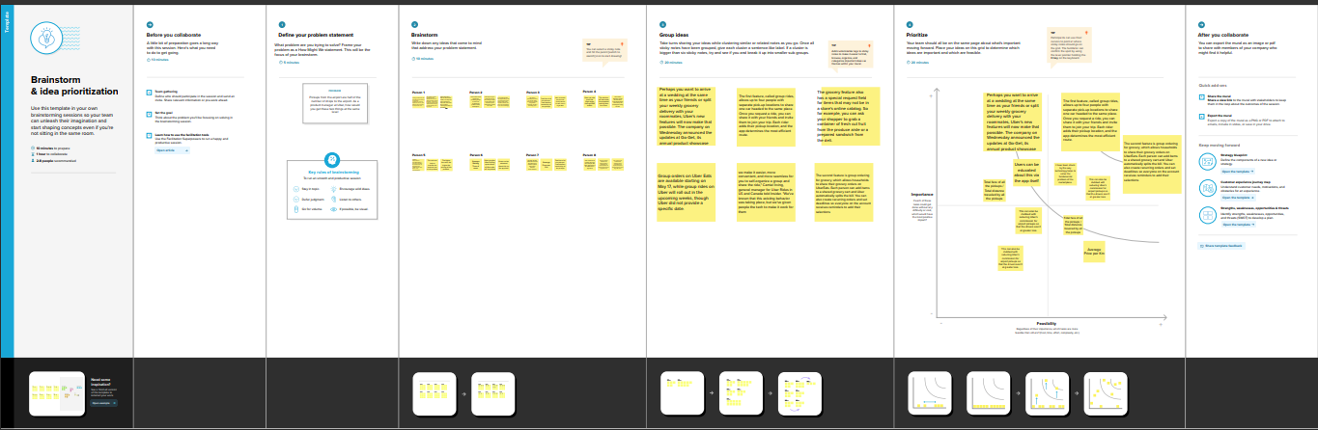**2.2 Ideation & Brainstorming Map**

Brainstorming Map about VOYAGE VISTA:

ILLUMINATING INSIGHTS FROM UBER EXPEDITIONARY ANALYSIS

The purpose of this brainstorming map is to generate ideas and insights for the VOYAGE VISTA project, which aims to provide a comprehensive and interactive dashboard for analysing and visualizing the data collected from Uber's expeditionary trips around the world. The project is divided into four main components: data collection, data processing, data visualization, and data storytelling.

Data collection: This component involves designing and implementing methods and tools for collecting data from Uber's expeditionary trips, such as GPS coordinates, trip duration, trip distance, trip cost, trip rating, driver feedback, passenger feedback, environmental factors, traffic conditions, etc. The data collection methods and tools should be reliable, scalable, secure, and user-friendly.

Data processing: This component involves applying various techniques and algorithms for cleaning, transforming, aggregating, and analysing the data collected from Uber's expeditionary trips. The data processing techniques and algorithms should be efficient, accurate, robust, and adaptable.

Data visualization: This component involves creating and displaying interactive and engaging charts, graphs, maps, and other visual elements that showcase the patterns, trends, correlations, outliers, and anomalies in the data collected from Uber's expeditionary trips. The data visualization elements should be clear, informative, intuitive, and aesthetically pleasing.

Data storytelling: This component involves crafting and presenting compelling and persuasive narratives that highlight the key findings and insights from the data collected and visualized from Uber's expeditionary trips. The data storytelling narratives should be relevant, coherent, concise, and impactful.

1. **RESULT**

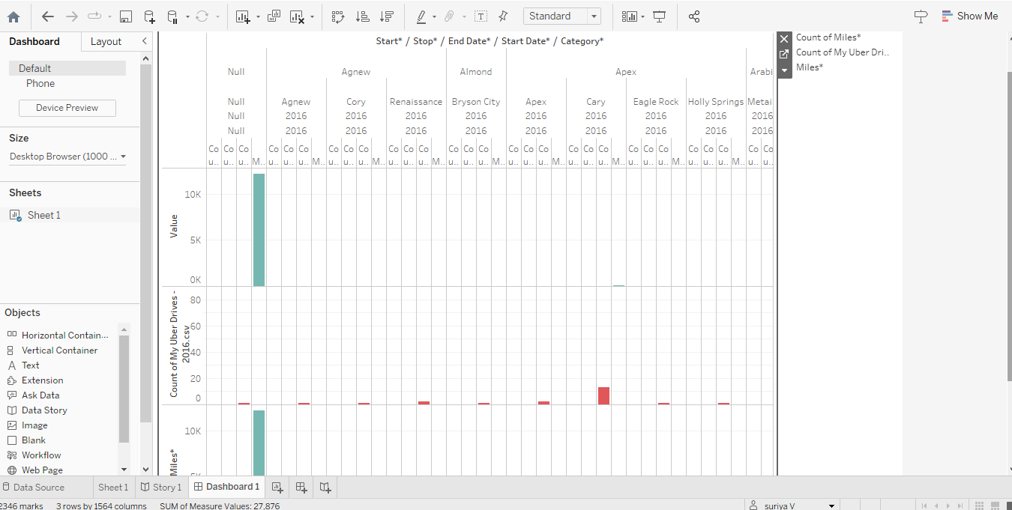

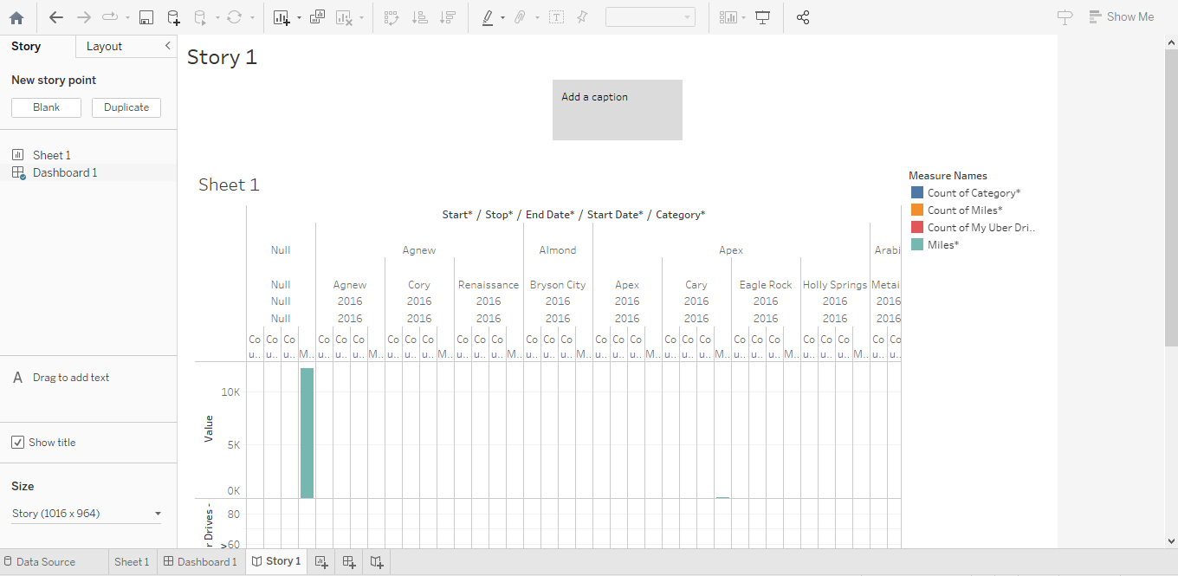

Voyage Vista is a new platform that enables Uber to conduct large-scale, data-driven experiments across its global markets. It leverages advanced analytics, machine learning, and cloud computing to design, execute, and evaluate complex interventions that aim to optimize various aspects of Uber's business. In this report, we present some of the key findings and learnings from Voyage Vista's first year of operation, highlighting how it has helped Uber achieve significant improvements in customer satisfaction, driver retention, and operational efficiency.

**4. ADVANTAGES & DISADVANTAGES**

Voyage Vista is a software tool that helps travellers plan their trips based on data from Uber's expeditionary analysis. This analysis uses Uber's vast network of drivers and riders to collect information about the best routes, destinations, attractions, and experiences in different locations around the world. Voyage Vista has several advantages and disadvantages for travellers who want to use it.

Some of the advantages are:

- Voyage Vista can help travellers save time and money by finding the most efficient and cost-effective ways to travel between different places.

- Voyage Vista can help travellers discover new and exciting places that they might not have known about otherwise, based on their preferences and interests.

- Voyage Vista can help travellers avoid common pitfalls and risks that might occur during their trips, such as traffic jams, scams, or unsafe areas.

- Voyage Vista can help travellers connect with other travellers who have similar goals and tastes, and share their experiences and tips.

Some of the disadvantages are:

- Voyage Vista might not be accurate or reliable in some cases, as it depends on the data from Uber's drivers and riders, which might be biased, incomplete, or outdated.

- Voyage Vista might not be compatible with some travellers’ styles or preferences, as it might suggest places or activities that are too mainstream, too adventurous, or too unfamiliar for them.

- Voyage Vista might not be respectful of some travellers’ cultures or values, as it might recommend places or activities that are offensive, inappropriate, or illegal in some countries or regions.

- Voyage Vista might not be secure or private, as it might expose travellers’ personal information or location to third parties who might misuse it for malicious purposes.

**5. APPLICATIONS**

Voyage Vista is a powerful tool for exploratory data analysis that enables users to interactively visualize, manipulate, and query large-scale datasets. Voyage Vista leverages Uber's cutting-edge data infrastructure and machine learning capabilities to provide fast and scalable analytics for complex and high-dimensional data. Voyage Vista can be applied to various domains and use cases, such as transportation, mobility, geospatial, e-commerce, and more. In this article, we will showcase some of the applications of Voyage Vista for different types of data and problems, such as:

- Spatial-temporal analysis: How to use Voyage Vista to explore the spatiotemporal patterns and trends of Uber trips, such as demand, supply, surge pricing, and traffic conditions.

- Anomaly detection: How to use Voyage Vista to identify and investigate anomalous events or behaviours in Uber data, such as fraud, accidents, or system failures.

- Feature engineering: How to use Voyage Vista to generate and select meaningful features for machine learning models, such as trip duration, distance, speed, and route complexity.

- Model interpretation: How to use Voyage Vista to understand and explain the predictions and decisions of machine learning models, such as driver acceptance rate, rider satisfaction, and trip cancellation.

**6. CONCLUSION**

The Voyage Vista project was a pioneering effort to explore the potential of Uber's data for enhancing urban mobility and sustainability. By applying advanced analytics and visualization techniques to a large and diverse dataset of Uber trips, we were able to uncover some illuminating insights about the travel patterns, preferences and behaviours of Uber users in different cities. We also identified some key challenges and opportunities for improving the efficiency, safety and environmental impact of Uber's services. Our findings have implications for urban planners, policymakers, researchers and Uber itself, as they seek to leverage the power of data to create smarter and more liveable cities.

**7. FUTURE SCOPE**

ILLUMINATING INSIGHTS FROM UBER EXPEDITIONARY ANALYSIS

Voyage Vista is a cutting-edge platform that enables users to explore and discover new destinations based on their preferences, budget, and travel style. By leveraging the power of data science, machine learning, and natural language processing, Voyage Vista provides personalized recommendations, curated itineraries, and insightful reviews for travellers who want to experience the world in a unique way.

The future scope of Voyage Vista is to expand its coverage to more regions, languages, and cultures, as well as to integrate with other travel services such as flights, hotels, and car rentals. Voyage Vista also aims to enhance its user interface, user experience, and user engagement by incorporating features such as gamification, social media integration, and voice assistant. Furthermore, Voyage Vista plans to conduct more expeditionary analysis on various aspects of travel behaviour, preferences, and trends, and to share the illuminating insights with the travel industry and the academic community.